Today we will explore the disaster effects caused by a meteorite impacts close to Metro Vancouver. To do this we will use the asteroid launcher from this website to generate some big impacts!

<https://neal.fun/asteroid-launcher/> (or search for asteroid launcher)

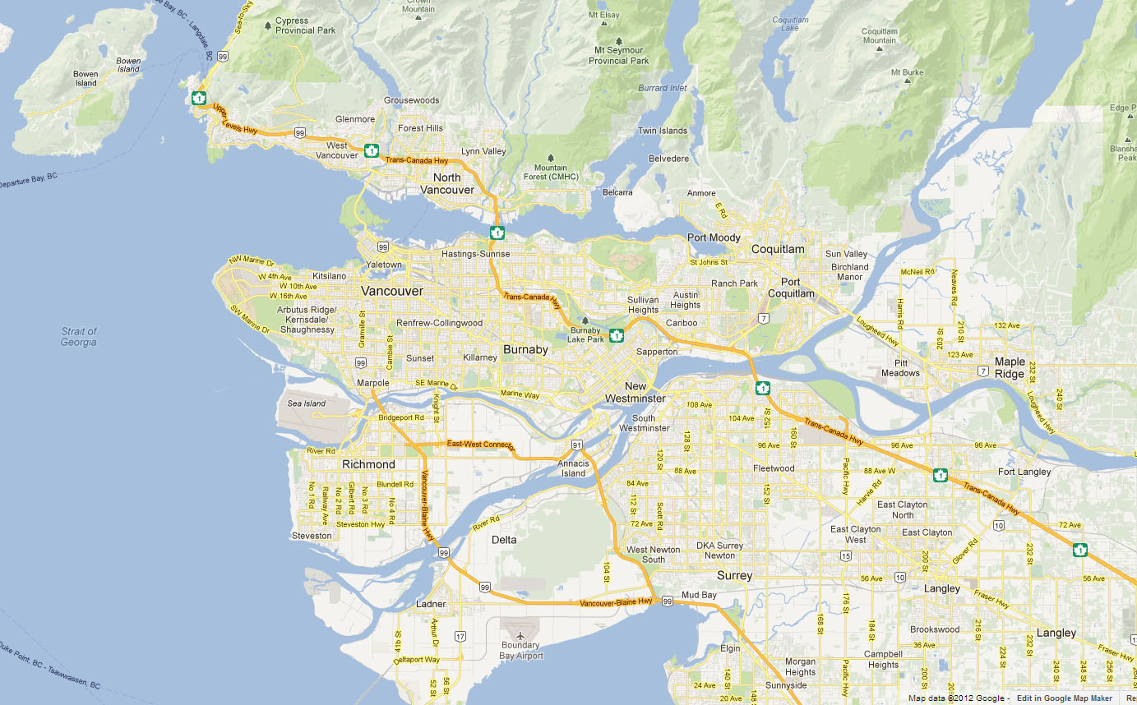**Assume the meteorite will hit Bowen Island.**

**First open Google Maps and use the distance tool to measure how far UBC is from our impact site on Bowen Island.**

**Answer = __~14 _ km**

1. Now let’s look a few different sizes/densities of impactors. Enter the parameters for each question below into the asteroid launcher. Scroll down and look at the “effects” then discuss in your group what you think the three most hazardous effects are for us at UBC, and for people at UVic in Victoria. Include details like tsunami height, energy released in Gigatons of TNT, fireball, shockwaves, windspeeds and earthquake magnitudes!
   1. Projectile Diameter: **60 m**; Asteroid type: Comet (ice); Speed **51 Km/s**; Impact angle **45°**

Airburst – the largest in recorded history, 18 megatons of TNT, 1 in 1,000 year event

* 1. Projectile Diameter: **60 m**; Asteroid type: **iron**; Speed: **20 Km/s**; Impact angle **45°**

263 m wide crater, 4 people vaporized, 101m tall tsunami, 3 megatons of TNT, 1 in 1,000 yr event

Shockwave and winds – but at UBC we wouldn’t feel it….but it would be an amazing sight! Would the tsunami get us? YES!

* 1. Projectile Diameter: **500 m**; Asteroid type: **iron**; Velocity: **20 Km/s**; Impact angle **45°**

Bigger crater – 3.7 km, 891 m tall tsunami, 1104 people vaporized, more energy released than the world consumes in 1 year, 16 Gigatons TNT, 1 in 213,000 yr event.   
UBC in the fireball where clothes catch on fire, 99% fatalities from the shock wave, winds >1,500 km/h, AND…as if we need more, a Magnitude 6.1 Earthquake

* 1. Projectile Diameter: **500 m**; Asteroid type: **iron**; Velocity: **20 Km/s**; Impact angle **90°**

Changing the impact angle – **bigger crater 5.3 km, 1 km tsunami, 1484 people vaporized**,more energy released than the world consumes in 1 year, 16 Gigatons TNT, 1 in 213,000 yr event.   
UBC in the fireball where clothes catch on fire, 99% fatalities from the shock wave, winds >1,500 km/h, AND…as if we need more, a **Magnitude 6.3 Earthquake**

1. Let’s get messy. Increase the size of an **Iron Asteroid**, travelling at **100 km/**s, impacting at **45°,** make a note of the minimum size of an asteroid that will cause the following :
2. UBC is completely consumed by the crater ~1.3 km diameter
3. Kelowna experiences 50% fatalities from the fireball ~730 m diameter
4. Homes in Calgary collapse due to the shockwave ~850 m diameter
5. People in Whistler would feel like they are in an EF5 tornado ~170 m diameter

1. Fine. Hit it with the biggest one the program allows – 1.5 km diameter. See if I care. Do your parents know what you are doing? What would people experience in Saskatoon and San Francisco?

Saskatoon – trees knocked down by the wind   
San Francisco – Homes collapse from the shock wave, trees knocked down by the wind

1. What size was the asteroid that wiped out the non-avian dinosaurs? 10-15 km  
   When did this extinction event happen? 65 Ma  
     
   4) From the homework….if you remember it. How big was the largest NEO that made its closest approach in September 1918?   
   720m – 1.6 km